IED Line-Following Car Competition
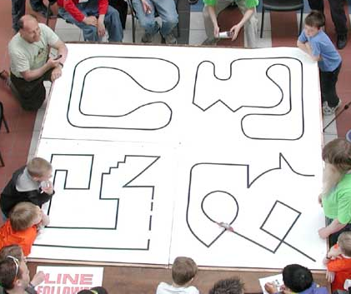
Introduction:
The goal of this competition is to build the sensor and drive circuitry to run a battery-powered line-following robot. The vehicles will all be built from the same provided motor and chassis kit. This will allow teams to focus on the electrical and control subsystems, rather than the mechanical components.
Background:
Each group will construct a line-following car to travel a specified course (see Figure 1), in as short a time as possible, without running off the track. The actual course design will be disclosed by the instructor on the day of the competition. As accuracy and consistency are critical in engineering, scoring will be calculated based on these parameters.
Figure 1 - Four Line-Follower courses at a competition
Your role on this project is a “Junior Engineer”. The market segment and overall goals have been established through corporate strategy meetings and quarterly forecasting. The project timeline, constraints, and specifications have already been identified by senior engineering staff. Your task as a junior engineer is to work within the given timeline to generate concepts, construct a prototype, and conduct initial testing and verification for a device that meets the specifications and constraint given to you.
Constraints:
- The car must be safe to operate. Any project deemed unsafe by an instructor will not be allowed to participate in the performance competition. If you have questions or concerns, TALK TO YOUR INSTRUCTOR BEFORE PROCEEDING!
- The ONLY method of control for the car must be built into the car.
- The car cannot be assisted once released from the starting line. Exceptions are made if and only if the car goes off course. Details are outlined in the Procedures section.
In addition to these constraints, your group’s launcher must meet the specifications found in Table 1. The table shows the individual specifications or ‘metrics’ for your launcher, as well as the target values and appropriate units for each.
Table 1 - Specifications
Specifications | Target value | Unit
Voltage | <= 24 | Volts
Course line width | 3/4 ± 1/16 | In
Minimum speed | >= 1.2 | In/sec
Maximum width | <= 12 | In
Maximum Length | <= 12 | In
Maximum Height | <= 83.5 | In

Benchmarking Results:
The other engineers assigned to this project have already looked at some competing designs and have determined that:
- Analog circuitry, discrete logic (e.g. 7400 series ICs) or microcontrollers may be used.
Your group should do additional benchmarking to learn more about how others have addressed this design problem. You may find existing solutions to borrow concepts from, as well as insight into how they may be fabricated.
Recommendations:
Background research on other line-following cars (including build logs and videos) can help with your design. A identification and understanding of the control method involved will help you model the operation and performance of your device. Major factors that should be considered and addressed in the course of the design process include optimal sensor configuration/placement, robustness under variable lighting conditions, and speed vs. accuracy. Motor & chassis kits are available for purchase from The Design Lab staff. A practice course (Figure 2) is available on LMS for printing, and a physical copy is located in the IED Shop for testing purposes.
The Competition:
Each of the three courses will be printed on E size paper (34” x 44”, see Figure 2). Line width is approximately 3/4”. The grading equations (provided in the grading spreadsheet available on LMS) are based on a course of this size. Each team’s car will attempt to traverse three courses. The Basic Course will consist of straight sections and curves. The Intermediate and Advanced Courses will contain sharper corners, tighter curves, and crossovers.
44”
Figure 2 - An overhead view of the practice course
34”
In Class Competition Day:
On the day of the competition, the three courses will be revealed to the class. Each team will have fifteen minutes to complete ALL practice and ALL scored attempts.
Procedure:
The car will be placed at the starting point on the track, powered on and allowed to travel the course. If the car goes off course, a team member will return it to the previous checkpoint. If the car goes off course again without completing the same section, a team member will place it at the next checkpoint, but will not earn points for completing that section of track. Other than these exceptions, no interaction with the car is allowed. The car may have as many attempts as necessary within the available time.

Competition Scoring:
Acceptable Car 10 pts
Working Car 30 pts
Complete Basic Course 42 pts
Complete Intermediate Course 9 pts
3 pts/completed section
Complete Expert Course 9 pts
3 pts/completed section
Total Performance Score 100 pts
The competition will be scored as shown in Figure 3 and as detailed below.
Acceptable car:
This score is 10% of the total performance score. It ensures that the car abides by the rules.
Working car:
Figure 3 – Competition Scoring
This score is 30% of the total performance score. It ensures that the car functions:
- follow a straight line without veering off (10 pts)
- follow a simple curved line to the left (10 pts)
- follow a simple curved line to the right (10 pts)
Complete Basic Course
This score is 42% of the total performance score. It requires that the car is capable of traversing the entire length of the basic course.
- complete section 1 (between checkpoints 1 and 2) (10 pts)
- complete section 2 (between checkpoints 2 and 3) (10 pts)
- complete section 3 (between checkpoints 3 and 1) (10 pts)
- complete the entire course without human intervention (12 pts)
Complete Intermediate Course
This score is 9% of the total performance score. It requires that the car is capable of traversing the entire length of the intermediate course within 120 seconds. The intermediate course will have three checkpoints. If the car goes off course, a team member will be allowed to place the car at the start of the failed section. If the car goes off course again without reaching the next checkpoint, a team member will place the car at the next checkpoint. 3 points will be awarded for each completed section. The car will be required to run two laps. Course length is 9 ± 1 feet.
Complete Expert Course
This score is 9% of the total performance grade. It requires that the car is capable of traversing the entire length of the difficult course within 240 seconds. The difficult course will have three checkpoints and is graded similar to the intermediate course, with 3 points awarded for each completed section. The car will be required to run two laps. Course length is 22 ± 2 feet.
Testing Performance:
An excel spreadsheet Line-Follower Scoring Sheet is available on LMS which determines the group’s performance grade. The basic scores, the time taken to complete advanced courses, and the number of completed sections will be entered into the calculator. The calculator adds the points for completed sections of the Intermediate and Expert courses. If the time taken is greater than the allowable time for a course, the team receives a zero for that attempt. The calculator then sums these scores along with the “Working Car”, “Acceptable Car”, and “Basic Course” scores to compute the overall performance score.
- Example: A team had an acceptable and working. It completed the Basic Course without intervention or assistance. The car consistently went off course in Section 1 of the Intermediate Course, but (with intervention) completed the course in 95 seconds. The car went off course consistently in sections 2 and 3 of the Expert Course but (with intervention) finished the course in 205 seconds.
Score = 10 + 30 + 42 + (3 x 2) + (3 x 1) = 91 pts
References:
- Line follower course image. Retrieved August 21, 2009 from Robot Games website: http://www.robotgames.net/robotgames/images/line-follower-DSCN5988.jpg

Tips for building a successful Line-Follower
Charles “Casey” Goodwin and Tony Peto
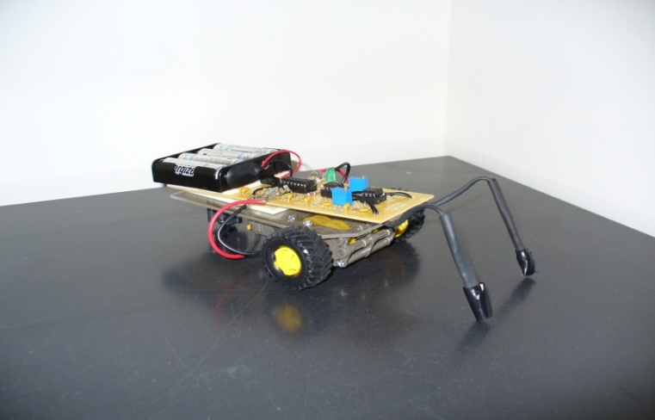
The objective of this project is to construct a system that follows a line. This challenge is intended to test the students’ ability to understand, create, and manipulate circuits to perform a desired task. As such, the circuitry you design can contain analog components (e.g. 741 op-amp, 2n2222 transistor), discrete logic (e.g. 7400 series logic chips), microcontrollers, or any mix of analog and digital logic (analog comparators are a good place to start). Many of these components are available in the parts bins in the IED Fabrication Shop (JEC 2232, ask a TA to show you). As a working line-follower can be constructed without a microcontroller, they are not provided. Students wishing to use a microcontroller must select and acquire their own.
Figure 4 - Line Follower constructed by Tony Peto
Summer 2009
Where to start:
Consider that a line follower is based around optical sensors. These detect varying light levels due to white paper or a black line on that paper. The result is a varying electrical signal (or several signals), which will drive some circuitry to control the speed of two electric motors. You are designing the sensor and other circuitry such that the electrical signals from the optical sensors affects control of the motors to keep the line-follower over the line as it moves forward along the course.
Consider how you would solve the problem - think about the different functions that the robot must accomplish (sensing, steering, etc...). Break down this approach into theoretical “functional blocks,” (a sort of pseudocode block diagram) and then construct your solution circuit to accomplish these blocks/functions.
Keep in mind:
- Simplicity - Keep it simple, just in case the car needs some major design changes/adjustments.
- Sensors - Put some thought into how your robot will detect the line. Remember to consider things such as ambient light, the width of the line (0.75 inches), and the position of the sensor bar in relation to the drive axle.
- Document your work - Throughout the design and construction process, document your team’s progress. Make notes that outline your decisions and thoughts throughout the process. Use circuit diagrams, flow charts, and block diagrams which will be helpful during the construction and debugging process. Use properly formatted and referenced diagrams and figures (like Figure 4) in your reports.

Circuitry Tips:
- Driving motors:
Do not try and drive the motor directly from logic output pins or Op-Amp output pins. Small DC motors such as the ones included in the kit can draw up to 3 or 4 amps (3000 – 4000mA) when “stalled” (i.e. not spinning due to excessive load). They draw around 300mA to 1 amp under normal conditions. Many integrated circuits (“chips”) cannot source more than about 20 mA (.02 amps), and can be damaged by excessive loads connected to their outputs. Instead, drive motors with power transistors (e.g. MTP3055, TIP122) or H-Bridge Drivers (e.g. SN754410, L298N).
- Electrical switching noise from the brushes in the DC motors can adversely affect your circuitry, and can sometimes cause erratic behavior. Connect a 0.1uF ceramic capacitor across the terminals of each of the two motors to prevent this.
- H-Bridge drivers typically take PWM (pulse width modulated) input. You can create a PWM signal with a 555 timer IC.
- You may wish to provide your own light source for your sensors (e.g. an LED). If using an LED (or LEDs), consider the spectrum to which your sensors are sensitive.
- Photoresistors vs. Phototransistors vs. Photodiodes vs. Photocells:
Be aware that the word “photocell” is used to refer to both photoresistors and photodiodes, which is sometimes confusing. Photoresistors are effectively light-sensitive variable resistors. Phototransistors are effectively light-sensitive transistors. Photodiodes are effectively very tiny solar cells. Many common circuits operate with photodiodes reverse biased (i.e. connected “backwards”) in what is known as photoconductive mode. There are electrical circuits in which photodiodes are operated unbiased (photovoltaic mode) as light-sensitive current sources.
- Batteries and voltage regulation:
It is likely you will power your line follower with batteries. Depending on what components you use, some voltage regulation may be needed (7400 series logic chips like 5.0V and do not last long when powered much above 5.5V). The common 7805 voltage regulator will provide an output voltage of 5V (when supplied an input voltage of 8V to 35V). If you use components that are capable of running at a wide range of voltages (e.g. 555 timer, 741 op-amp, TIP122 transistor), then such a voltage regulator may not be required. Check the data sheet if you are unsure.
- Data sheets:
Data sheets are available online. Often, electronics vendors (e.g. Mouser.com, Digikey.com) will link directly to the datasheet for a specific part, so search for the part through a vendor to save time. Different manufacturers who make the same part often each have their own datasheet. Standardized parts are usually very similar though, and in many cases, a competitor’s datasheet will be sufficient. (For the purposes of this class, the KA7805 datasheet from Fairchild semiconductor is adequate to describe the L7805 made by STMicroelectronics and vice versa.)
- Use multimeters, logic probes, and oscilloscopes! If you aren’t measuring what is going on in your circuit, you won’t know if it is functioning as you expect, and you have no hope of finding which part is not working. There are oscilloscopes, function generators, programmable power supplies, and bench multimeters in the IED Shop (JEC 2232). Electronics toolboxes and multimeters can be purchased in the RPI Bookstore.
Construction tips:
- Double-sided foam tape is a convenient way to attach your protoboard to the top of your line follower.
- Soldering wires to the electric motors’ terminal tabs will be more reliable than just passing wire through them and twisting it together. Also, twisting may damage the tabs, as they are thin. Soldering toolkits are available in JEC 2232 – ask the TA. There are good soldering tutorials available online. One such tutorial (with an excellent video and many links to other tutorials) can be found here: http://store.curiousinventor.com/guides/How_to_Solder
Here are a few links which may be helpful:
- Line follower using two infrared transistors
  - http://www.youtube.com/watch?v=F3vBX8p3xH0
- Explanation of Op-amps, which you may want to use in your design
  - http://talkingelectronics.com/projects/OP-AMP/OP-AMP-1.html
- Wikipedia article for photoresistors
  - http://en.wikipedia.org/wiki/Photoresistor
Books:
“The Essence of Analog Electronics” by Colin Lunn, 1996
“The Art of Electronics” by Paul Horowitz and Winfield Hill, 2nd edition 1989
Local Sources for Parts:
- IED Fabrication Shop - JEC 2232. First off try the parts cabinet!
- RPI Embedded Hardware Club – rpiehc.org
- Radio Shack‎ - 120 Hoosick St # 11, Troy, NY‎ - (518) 272-6348‎
  - selection may be limited, and costly
- Trojan Electronic Supply Co‎ - 15 Middleburgh St, Troy, NY‎ - (518) 274-4481
  - only open 8am-5:30pm, M-F

Online Sources for Parts:
Large electronics component distributors
- www.Mouser.com
- www.Digikey.com
- www.elexp.com
- www.newark.com
- www.alliedelec.com
- www.mcmelectronics.com
Robotics components
- www.Sparkfun.com
- www.solarbotics.com
- www.Pololu.com
Surplus electronics supplier - selection varied, changing, and inexpensive
- www.MPJA.com

